**BRAKING SYSTEM FOR HYPERLOOP**

A REPORT PRESENTED BY

Team Vegapod

**Dream. Innovate. Build**

**Overview:**

Hyperloop Technology has been conceptualised as a High speed mode of transportation, travelling long distances at high speeds. Such Systems would require braking systems that can keep the inertia and Lateral forces under control – both safely and economically. As the Speed of the Pod increases, the concern for safety rises. Brake technologies play an important role on the safety of the vehicle’s operation. To avoid accident, the shorter of braking distance is better. Traditional brake systems don’t have enough capacity to ensure quick, accurate and synchronized braking requirements. Thus, development of new braking system with high reliability and light weight is a key requirement.

The braking methods used in Hyperloop can be classified into two types: Contact type braking and non-contact type braking. In Contact type braking, the created force is limited by the maximum force between the Guide Rails and the Brake Pads; however, this limitation does not exist in non-contact type braking. In non-contact type Braking, the maximum braking force is a function of the Instant velocity of the Pod.

With such high speeds, the risk factor increases drastically. In order to account for that, the braking is divided into Primary and Emergency-type Braking. The Primary Braking is applied in cases of Usual acceleration and braking commands execution. However, in events of emergency such as sudden depressurisation, Failure of Battery/power Supply, faults in on-board Electronic functioning, the emergency brakes will bring the pod to an instant halt.

This Report summarises the use of High Pressure Pneumatic Braking System in Hyperloop. Using Pneumatic Braking system, lies in the very own characteristics. It is a Fail to Safe system, both in Primary and Emergency Braking Conditions. Ease of control and command execution are some of its advantages over Hydraulic/ Electro-Hydraulic Braking Systems.

**Introduction:**

While traditional methods suffice normal, more traditional modes of transport, they are not feasible for Hyperloop vehicles due to the high amount of energy they need to absorb. Hence, a new method was required. For an initial baseline idea, let us consider Trains, or High-Speed Railway systems. These mostly use some form of friction brakes for locking in conjunction with another non-adhesion type system to handle deceleration at large speeds, like electromagnetic brakes which engage on the track to produce eddy currents. Other systems include non-conventional methods like Ceramic Particle Jetting, which ejects ceramic particles onto the track to avoid slip, slide or to aid in emergency braking.

**Motivation:**

The above methods, while being very effective, also add to the weight of the vehicle. One of the major goals for the team is to reach the highest possible speed on our vehicle, hence increasing the weight is not in the best interests of the team. The team hence took upon the challenge to design a braking system that could handle heavy decelerations and still be lightweight, without causing much wear on the running track.

**Objectives:**

The most ideal braking system would be Linear Induction Motor itself, operating in the reverse pole condition, but its application is limited to high speeds, and offers very low brake retention at low speeds. The team marked the following as the basic objectives for the Braking system:

* Low weight
* Low required power
* Low actuation time
* High Deceleration
* Low track wear
* Fail Safe
* Compact size

While the cutting-edge solutions such as Magnetic and Reverse thrusters produce high deceleration values and generate almost none to low heat, they are heavy. Weight was a huge factor in the design of our Hyperloop vehicle, and hence it was prioritised over the problem of heat dissipation. The team hence decided to go with conventional friction brakes, with a change in the actuation system. The team chose Pneumatics over Hydraulics for the low actuation time, as well as low weight, and the low power requirements.

**Layout of the Testing Rig:**

The Principle of Testing rig is to simulate the Dynamic Braking conditions of an Hyperloop Pod. For the same, An Aluminium Disk is rotated at High Speeds and Frictional Brake Pads are actuated towards the Disk, to stop it in a stipulated Amount of time. This Suffices the Primary Braking Requirements. However, the conditions of emergency are simulated via Defined Electronic Controls, which mimics the Situation of Braking at High Speeds.

On the same Principle, a rigid Frame Structure is built to absorb the vibrations due to the rotating Inertia of the Disk. Upon the Frame, the Disk is Mounted on a Shaft which is coupled to the Driver, via a Belt and Pulley Mechanism. The Speed of the Shaft is continuously monitored via a DAS setup on a Local Server. The Data obtained is used to control the Active Pneumatic Braking Circuit parameters, responsible for producing the Braking Actions.

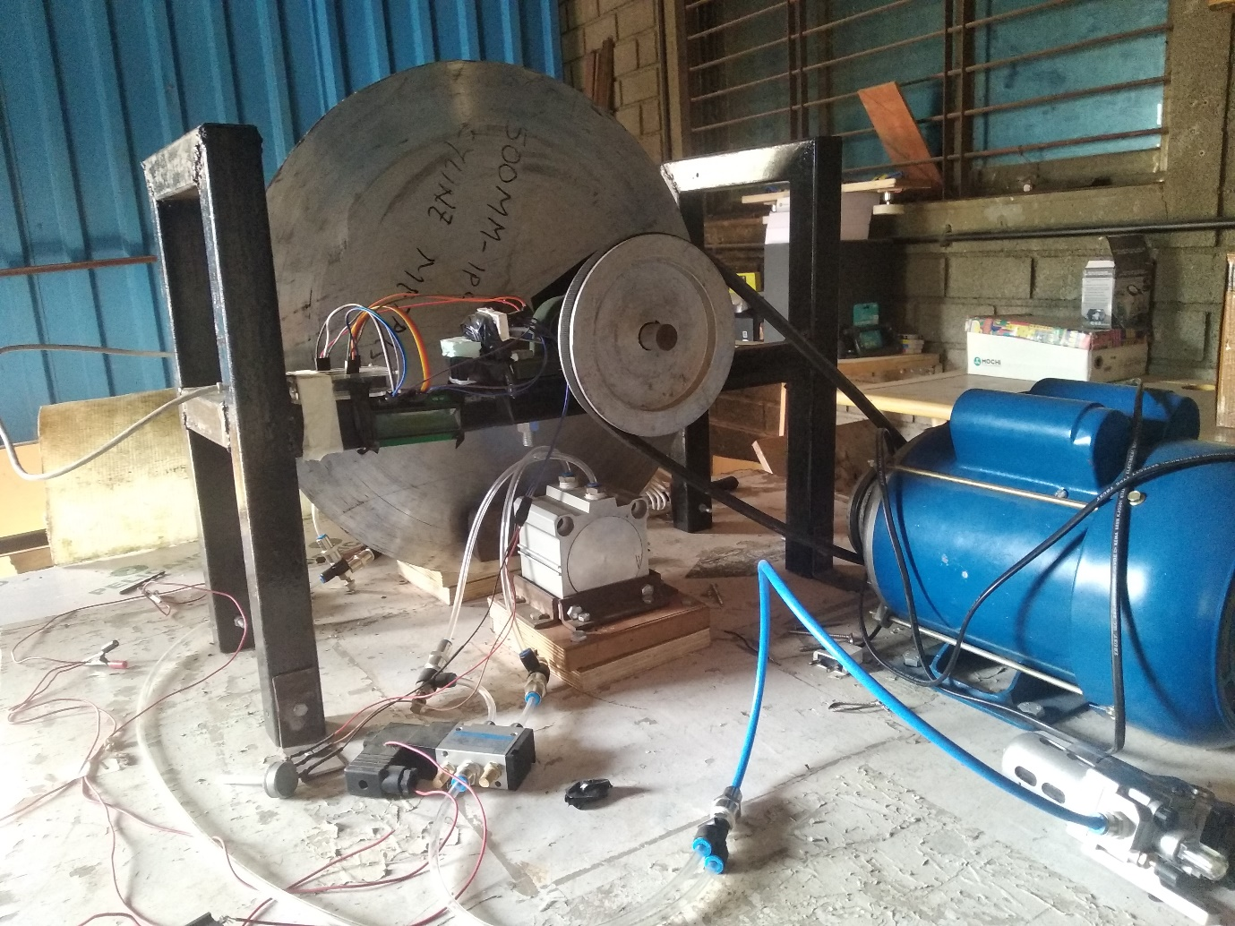

Fig 1. Test rig

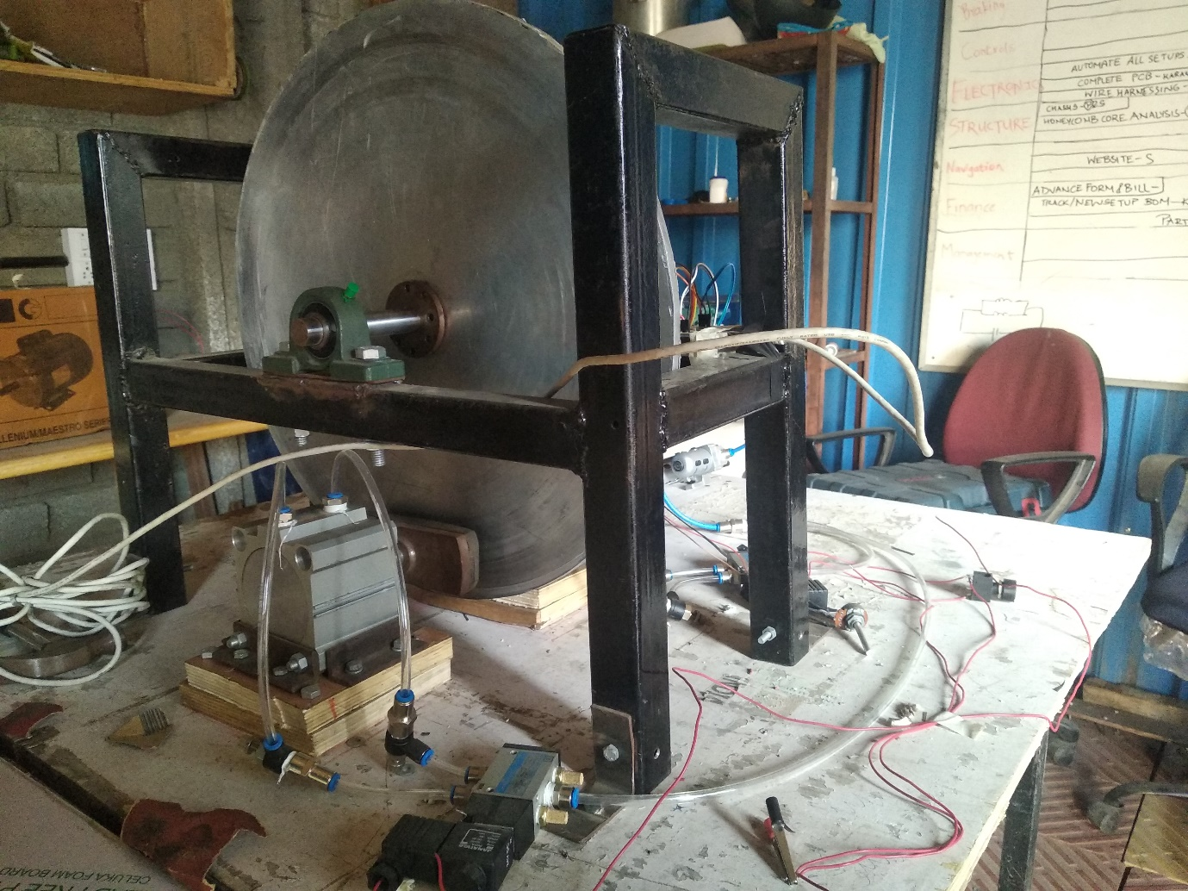

Fig 2. Test Rig

**Component Description:**

Following Components were utilised in the Testing rig, based on a set of Assumptions:

1. Braking Force should be able to Brake the disc from 100-0 km/hr in minimum amount of time.
2. Pneumatic Actuation pressure should not be more than 6 bars.
3. The Heat and Force Produced due to the braking action, should not hamper the Disc.
4. Produce Minimum vibrations while Braking and Acceleration of the Disk.

Aluminium Disk

1. The Aluminium Disk corresponds to the Web-Part of the I-Beam, on which the Pod is Supposed to Travel.
2. Diameter of the Disk: 500mm
3. Thickness of the Disk: 8mm
4. Material: Aluminium 6061 T-6 Grade

Metal Frame:

1. The Frame Structure was Designed and Built using Conventional Techniques.
2. The Rigidity of the Frame was kept large enough, to absorb Vibrations of the System, produced while Braking and Acceleration of the Disk.
3. Box Sections of Dimension 45mm*45mm*3mm were utilised to Design the Structure. Static Structural Analysis was Conducted on ANSYS 18.1 to know analyse the Deflection and Stresses generated.

Bearings and Shaft:

1. The Bearings and Shaft was chosen based on the Forces and Moment Transferred by the Belt and Pulley Drive.
2. Based on the Setup Arrangement, Pillow Block Bearings were used and Stainless Steel Shaft for Non-Corrosive and longer Durability.
3. (Mention the Bearing Dimensions).
4. (Mention the shaft Dimensions).

H-Bushings:

1. The H-Bushings were utilised to transmit the Forces from Shaft to the Disk.
2. Transmitting Motion using Only Keys, would lead to quick Failure of the System. Hence the Bushings were used.
3. The Bushings Were Manufactured In-house, using Conventional Turning and Drilling on a Stock Lathe Machine.
4. (Mention Dimensions).

Pulley-Belt Drive:

1. The Pulley-Belt Drive was Chosen due to the intermittent Distance between the Driver and Driven Shaft. Chain Drive Could be used as an Alternative but can lead to generation of Noises and would require Periodic Lubrication and Maintenance. Gears Box would be an efficient system but a more Expensive trade-off.
2. The System is used in a reducer manner, to decrease the Speed transmitted at same amount of Torque.
3. Larger Pulley has been Mounted of the Disk Shaft and the Smaller Pulley on the Shaft of the Rotor.
4. Large Pulley: 150 mm Diameter
5. Smaller Pulley: 100 mm Diameter
6. A V-Belt has been used, considering the amount of torque and to minimise losses in transmission.
7. Length of V-Belt: 1000mm

Motor:

1. An AC Motor has been used as a Driver of the System. Alternatives such as BLDC and DC motors can be used as well. However due to Fund constraints, we held to AC Motor for given Torque and RPM required.
2. RPM: 1440, Torque Input: 15Nm, Frequency: 50Hz, Vin: 230V/220V AC

Pneumatic System:

The Pneumatic System was used to the inherent nature of actuation in conditions of Failure. Also the System is easy to Control and Maintain, unlike Hydraulic Actuation where Stroke Rate is quite less as Compared to Pneumatic Counterparts. This helps in reducing Braking Time and Distance, which provides opportunity to reach higher speeds.

1. Actuators
   1. The actuators were outsourced according to given Design and Performance Requirements. A catalogue of actuators was studied to understand the differences in terms of stroke speed, response time, stroke length, loading capacity and more.
   2. (Mention Dimensions from the Janatics Page).
2. Pneumatic Circuit
   1. The Circuit is an Active Control Unit which can be controlled based on the acceleration conditions of the Disk.
   2. The Pressure and Air-Flow are two variables which are used to control the Braking Force applied by the Actuator.
   3. This gives us flexibility to simulate various conditions, before mounting the system on the Hyperloop Pod.

Brake Pads:

(Mention Brake Pad Properties from COMPO Brakes)

**Testing and Results:**

As the Motor starts rotating, the Force is transmitted via the Pulley and Belt Drive to the Shaft on which the Disk is Mounted. This leads to the Rotation of the Disk. The Speed of the Disk is continuously monitored by the proximity sensors mounted near the end of the shaft. This collects real time data, and transmits this via a Node-MCU to the Local Server setup. The Braking Signals are sent via this Server to the ECU, to actuate the Brake pads towards the Disk.

Several Test trials were conducted on the system, to understand Braking Pattern at various acceleration values. They have been Summarised below:

(Mention Test Results, if you have. Such as Braking Time, Speed of the Disk, Latency in Input Signal and actuation of Brake Pads. Attach photos of the HTML Page used to input signals to relay)

Trial Run of the test Setup: (Attach in the Footnotes if needed) <https://www.instagram.com/p/B7LBuuzHuTm/>

**References:**

1. **Mathematical Modeling & Analysis of Brake Pad for Wear Characteristics** S. R. Kakad1 , R.M. More, Dr. D. N. Kamble, Prof. S. R. Kakad, Department of Mechanical Engineering, SKNCOE, Pune, Prof. R.M. More, Department of Mechanical Engineering, SKNCOE, Pune, Dr.D.N.Kamble, Department of Mechanical Engineering, SAOE, kondhwa Pune.
2. **Modeling and Simulation Vehicle Air Brake System** Li He, Xiaolong Wang, Yunqing Zhang, Jinglai Wu, Liping Chen CAD Center, Huazhong University of Science and Technology, China [zhangyq@hust.edu.cn](mailto:zhangyq@hust.edu.cn)
3. <https://www.researchgate.net/publication/265819451_High-speed_train_pneumatic_braking_system_with_wheel-slide_protection_device_A_modelling_application_from_system_design_to_HIL_testing?enrichId=rgreq-41efecec7b0572f58cdf6a0cef105c2a-XXX&enrichSource=Y292ZXJQYWdlOzI2NTgxOTQ1MTtBUzoyMTc5NTMyMDg0MTAxMTJAMTQyODk3NTUwMjA5Mw%3D%3D&el=1_x_3&_esc=publicationCoverPdf>
4. **Impact Analysis of Brake Pad Backplate Structure and Friction Lining Material on Disc-Brake Noise**, Gongyu Pan and Lei Chen School of Automotive and Traffic Engineering, Jiangsu University, Zhenjiang 212013, China Correspondence should be addressed to Lei Chen; js_chenlei@126.com Received 29 December 2017; Accepted 7 March 2018; Published 29 March 2018.